**ReassignZipIdTest  
09/11/2020 21:08:50**  
User Is Navigated To Site : http://172.19.9.53/ICRARevamp/#/login  
  
*****ReassignZipIdTest is Started *****  
Username is entered  
  
Password is entered  
  
Submit button is clicked  
Text of the element : Successfully logged in  
Successfully logged in  
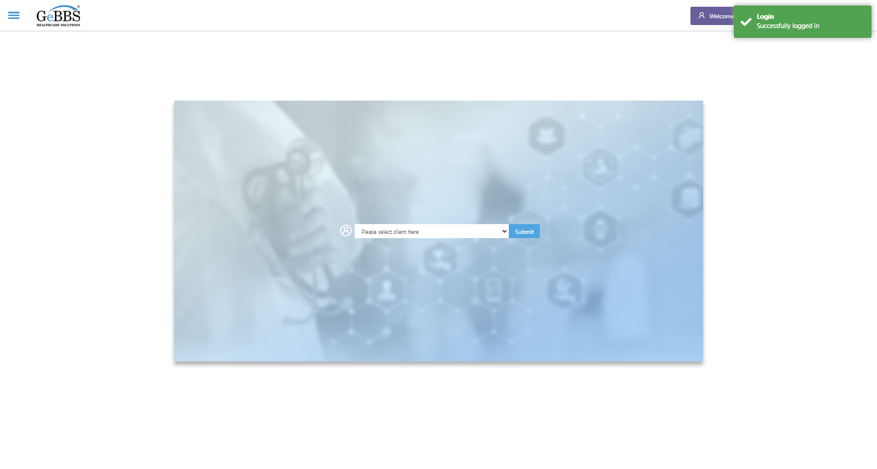  
Client dropdown button is clicked  
Client dropdown button is clicked  
Submit button is clicked  
Main Page loaded  
  
Scrolled successfully  
Call Center is clicked  
All submenus  
  
Submenu in 1 is :Address Allocation  
Submenu in 2 is :Address Approval  
Submenu in 3 is :Address Rollup  
Submenu in 4 is :Data Upload  
Submenu in 5 is :Inbound Call  
Submenu in 6 is :Manager Address Rollup  
Submenu in 7 is :PNP Exception  
Scrolled successfully  
Address Allocation is clicked  
Address Allocation selected  
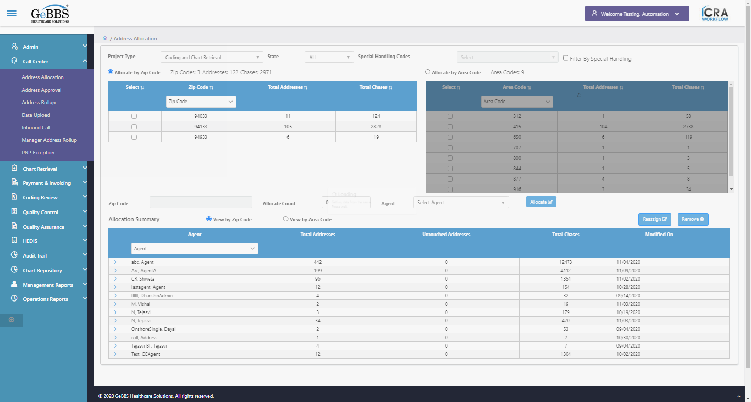  
Agent Found  
Total count of Addresses In Summary Table :0  
Total count of Chases In Summary Table :154  
Zip Code,Address Count,Chase Count In Heading Is Taken Before Allocation  
Allocate is clicked  
Text Is Correct  
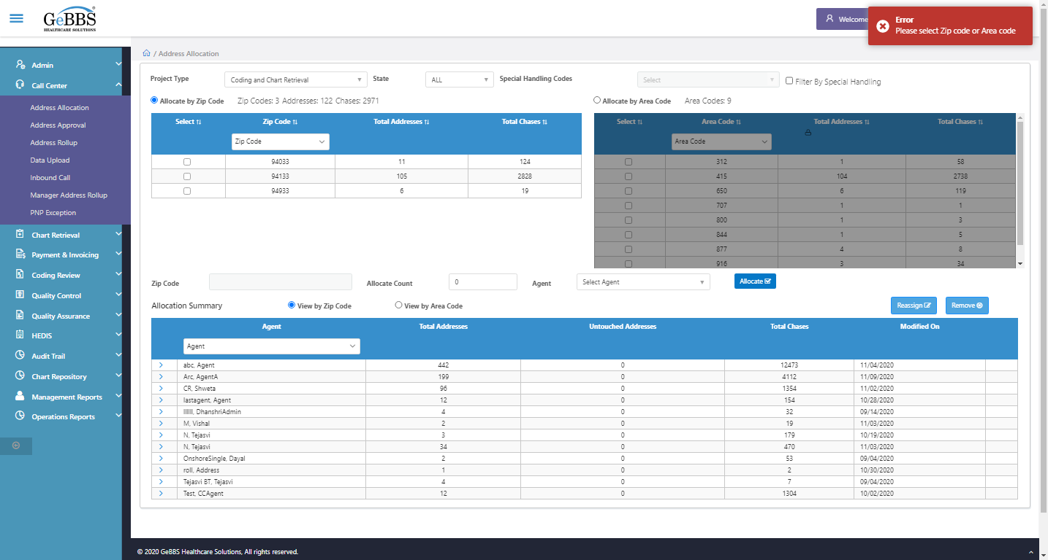  
Zip Code,Address Count,Chase Count In Zip Code Table Is Taken Before Allocation  
Zip code is clicked  
Agent is clicked  
AgentName is clicked  
Allocate is clicked  
Text Is Correct  
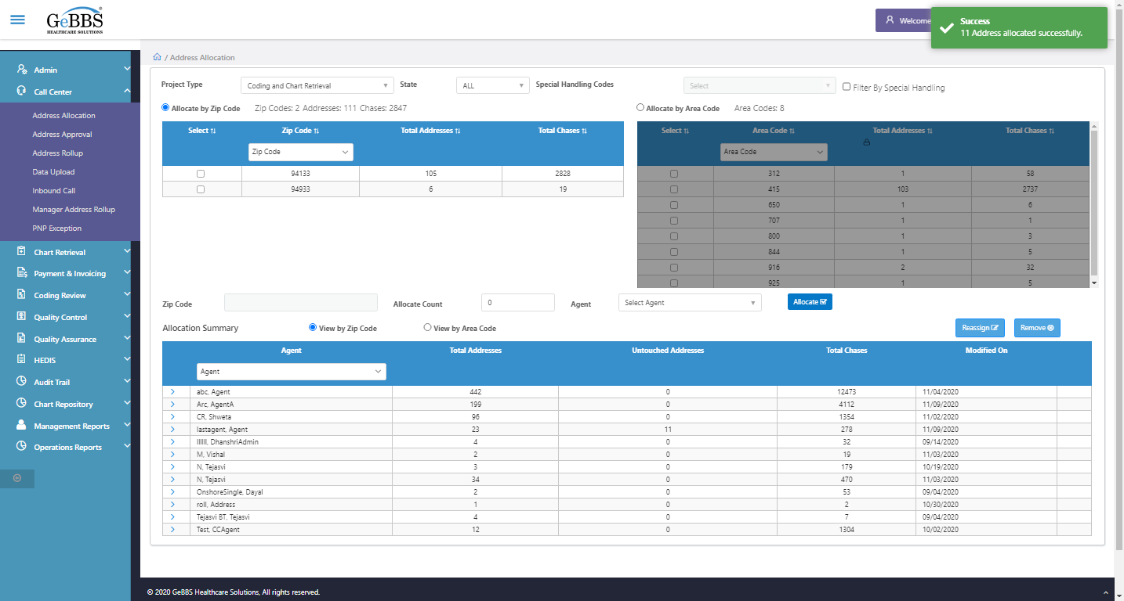  
======== ZipCode is allocated =============  
Zip Code,Address Count,Chase Count In Heading Is Taken After Allocation  
Count of zip in header is correct  
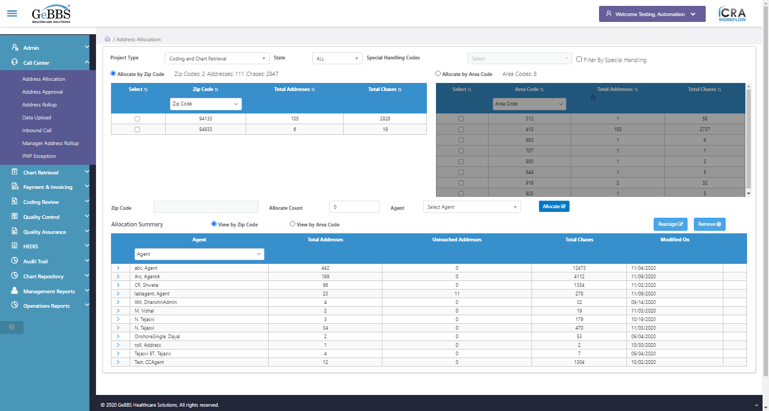  
Count of Address in header is correct  
  
Count of Chases in header is correct  
  
Zip id assigned and checked Header Count  
Zipcode Textbox is clicked  
Zip Id is entered  
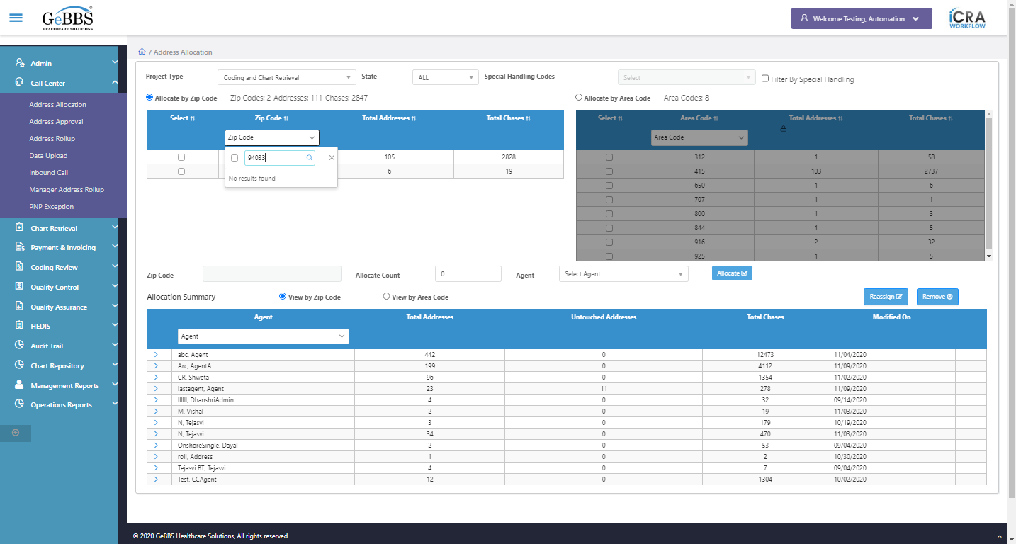  
Address Count is Zero i.e correct  
  
Checked Zip Id in zip code table  
Total Untouch address count is correct in summary  
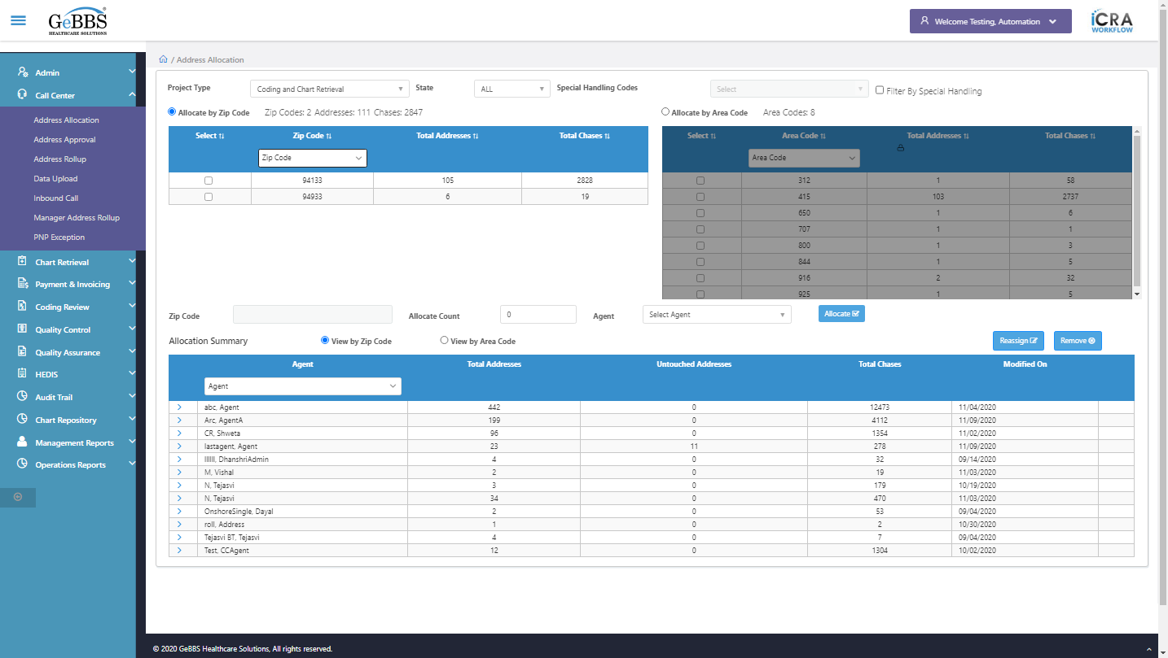  
Chase Count In Summary Table is added  
  
Checked total Untouch and Chase Count in Allocation Summary table  
Scrolled successfully  
> sign is clicked  
Clicked on > sign of that agent  
Code is entered  
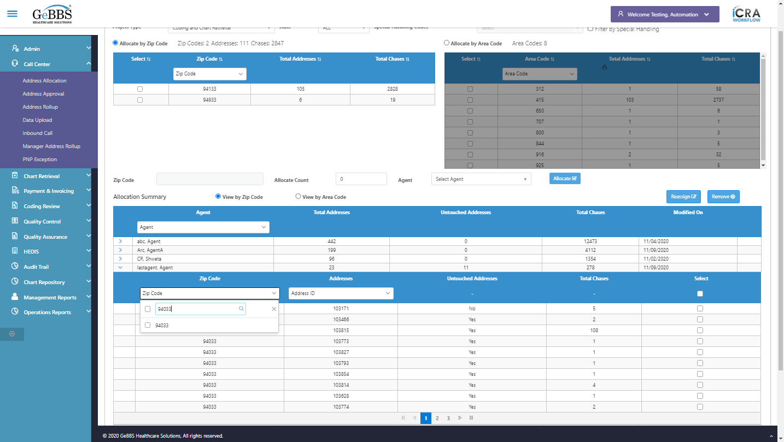  
checkbox is clicked  
Close is clicked  
Id is present in Summary table  
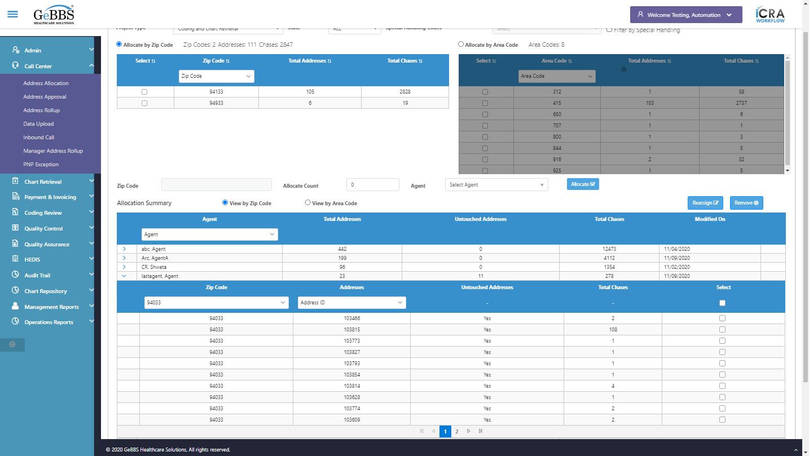  
Username is entered  
  
Password is entered  
  
Scrolled successfully  
Submit button is clicked  
Client dropdown button is clicked  
Client dropdown button is clicked  
Submit button is clicked  
Mainmenu is clicked  
Submenu is clicked  
Address Allocation is selected  
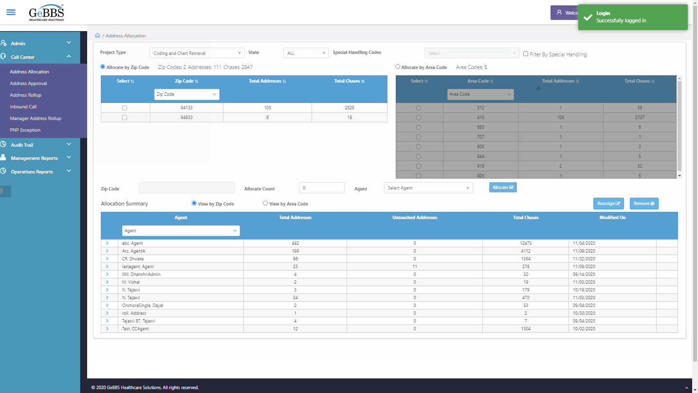  
Address Rollup is clicked  
Element is clicked  
Element is clicked  
Zip id is clicked  
ZipTextbox is entered  
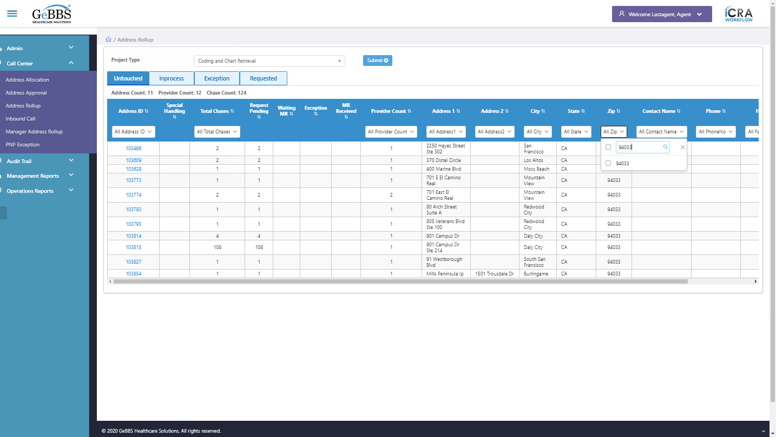  
chkbox is clicked  
Id is present in RollUp  
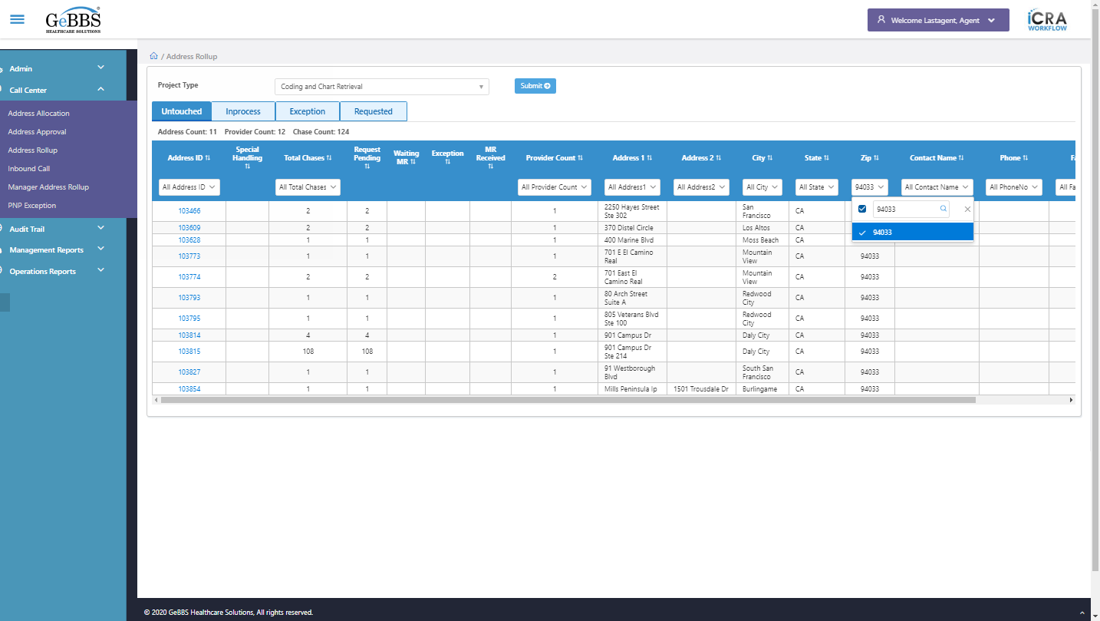  
close is clicked  
Checked in RollUp screen  
*************** Assiging ZipCode Test Is Ended **********  
*************** Reassiging ZipCode Test Is Started **********  
Username is entered  
  
Password is entered  
  
Submit button is clicked  
Text of the element : Successfully logged in  
Successfully logged in  
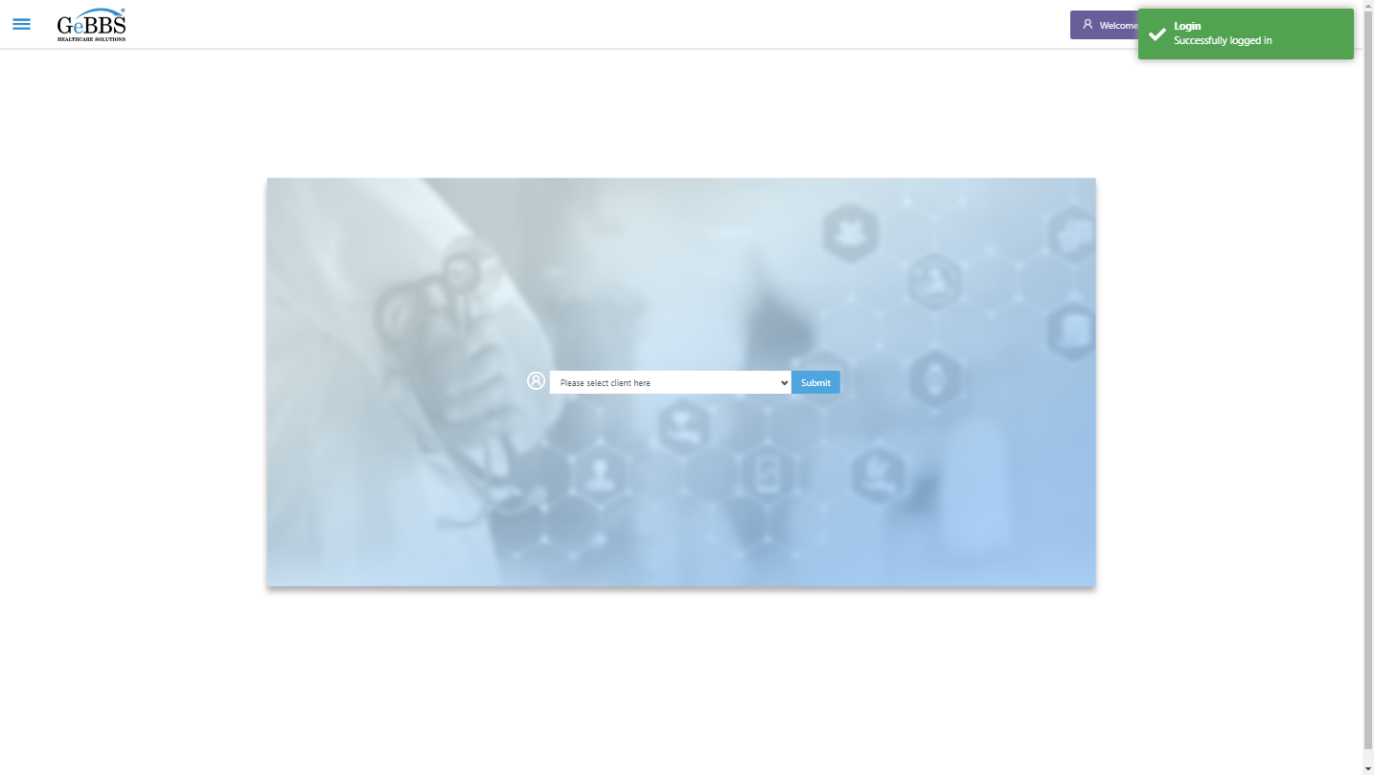  
Client dropdown button is clicked  
Client dropdown button is clicked  
Submit button is clicked  
Mainmenu is clicked  
Submenu is clicked  
Address Allocation is selected  
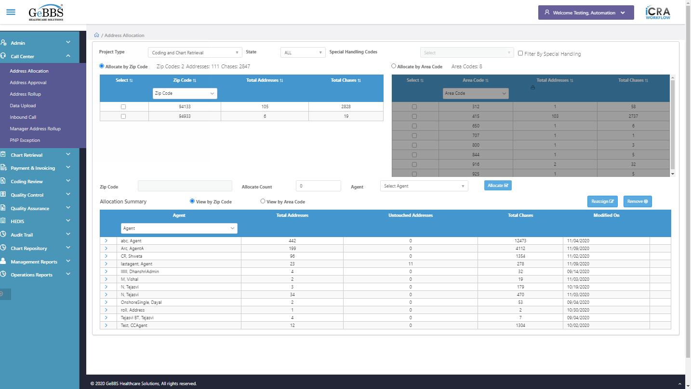  
Agent Found  
Total count of Addresses In Summary Table :11  
Total count of Chases In Summary Table :278  
Agent Found  
Total count of Addresses In Summary Table :0  
Total count of Chases In Summary Table :12473  
Scrolled successfully  
Sign is clicked  
Scrolled successfully  
Scrolled successfully  
Reassign is clicked  
Untouch chase count in reassign winodow is correct  
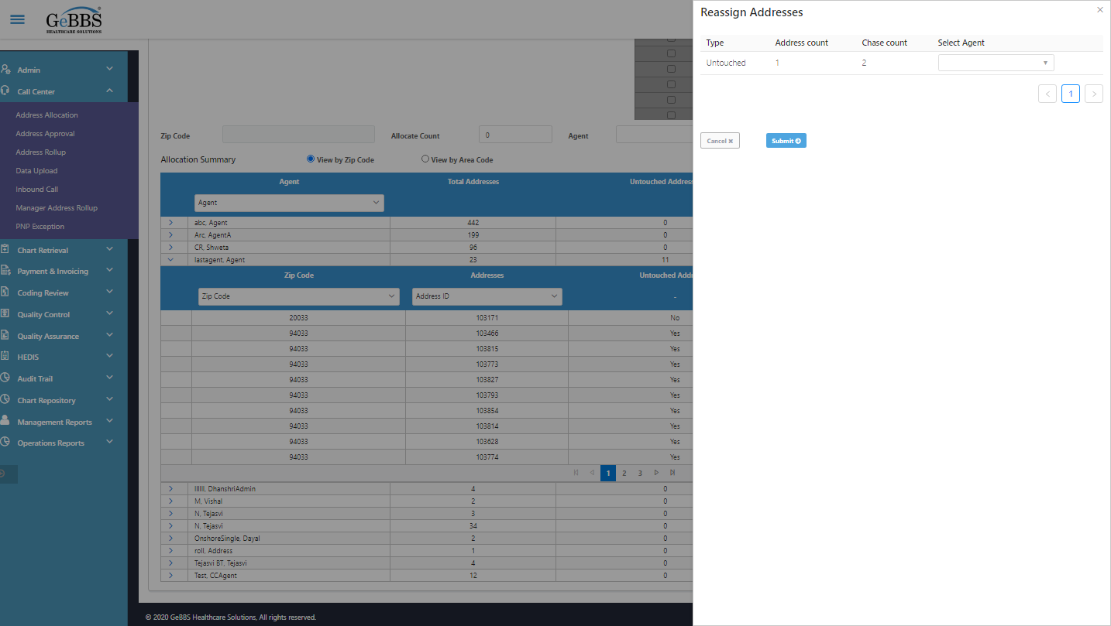  
Checked Untouch chase count in reassign window  
Agent_Reassign is clicked  
AgentName is clicked  
Submit_Reassign is clicked  
Text Is Correct  
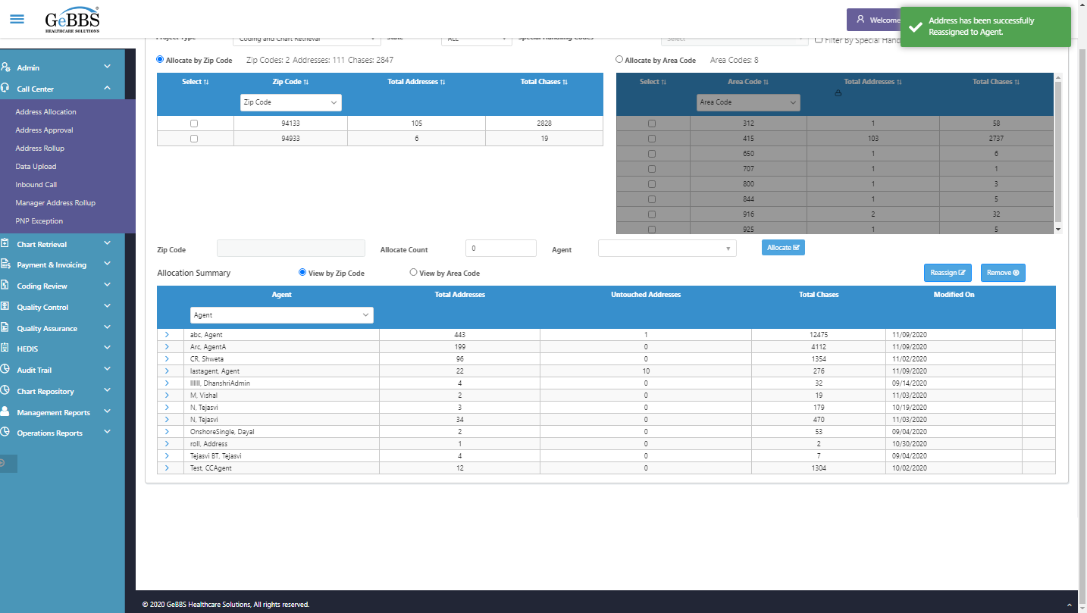  
Agent Found  
Total count of Addresses In Summary Table :10  
Total count of Chases In Summary Table :276  
Agent Found  
Total count of Addresses In Summary Table :1  
Total count of Chases In Summary Table :12475  
Total Untouch Address Count Of Old Agent of Summary table before reassign:11  
Total Untouch Address Count Of Old Agent of Summary table after reassign:10  
Total Untouch Address Count Of New Agent of Summary table before reassign:0  
Total Untouch Address Count Of New Agent of Summary table after reassign:1  
Checking Total Untouched Address Count Of Reassign Agent...........  
Total Untouch address count of new agent after reassign is correct  
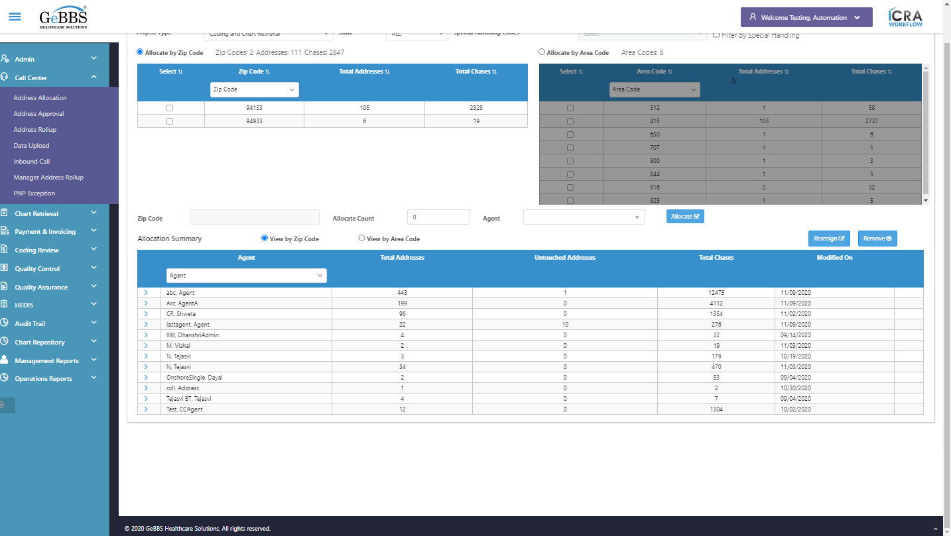  
Checking total Untouched Address Count Of Old Agent...........  
Total Untouch address count of Old agent after reassign is correct  
  
Total Chase Count Of Old Agent of Summary table before reassign:278  
Total Chase Count Of Old Agent of Summary table after reassign:276  
Total Chase Count Of New Agent of Summary table before reassign:12473  
Total Chase Count Of New Agent of Summary table after reassign:12475  
Total Chase Count is correct In Reassign Agent  
  
Checking Total Chase Count Of Old Agent...........  
Total Chase Count is correct In Old Agent  
  
Scrolled successfully  
> sign is clicked  
Clicked on > sign of that agent  
Code is entered  
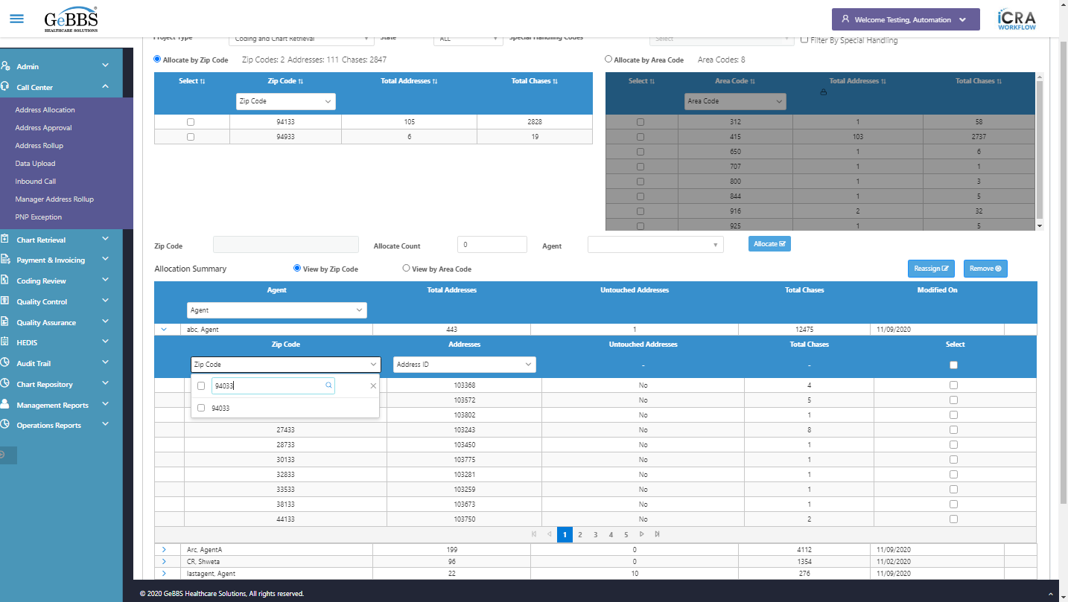  
checkbox is clicked  
Close is clicked  
AddressId is entered  
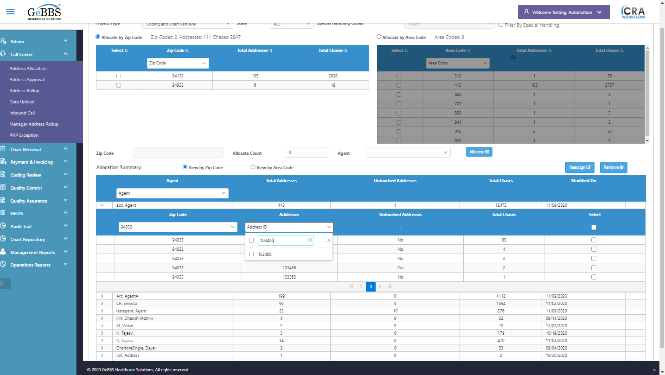  
checkbox is clicked  
Close is clicked  
Id is present in Summary table  
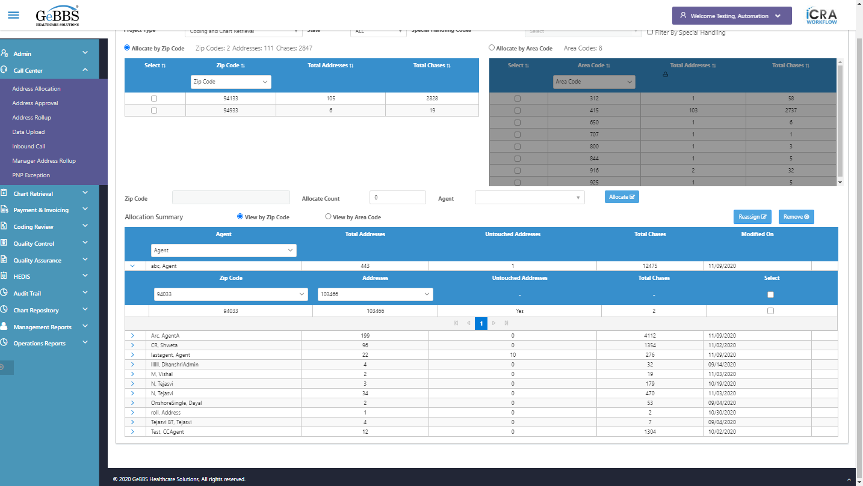  
Address Id in Summary table is correct  
  
Chase count in Summary table is correct  
  
Username is entered  
  
Password is entered  
  
Scrolled successfully  
Submit button is clicked  
Client dropdown button is clicked  
Client dropdown button is clicked  
Submit button is clicked  
Mainmenu is clicked  
Submenu is clicked  
Address Allocation is selected  
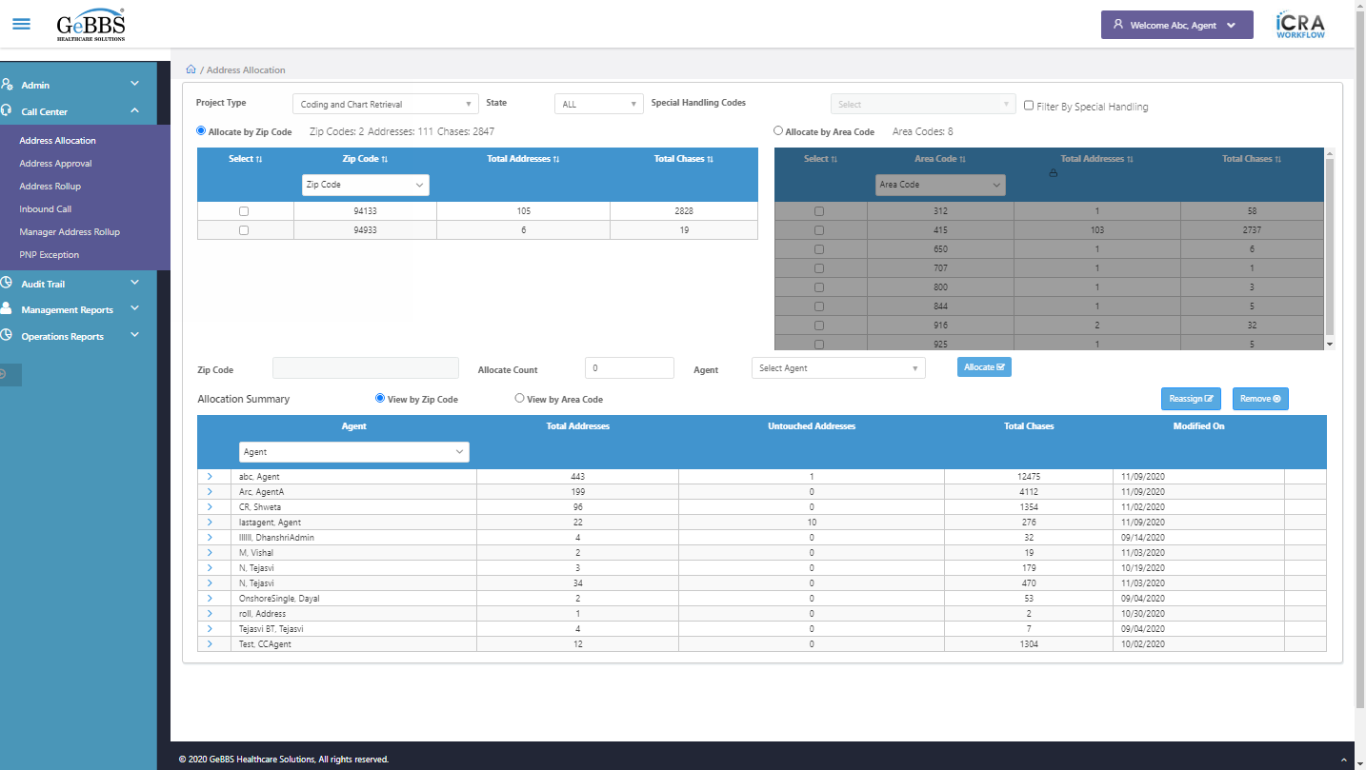  
Address Rollup is clicked  
Element is clicked  
ChkAdrRollUpForReassgin() failed **09/11/2020 21:12:00**